Deep learning models for predicting the survival of patients with medulloblastoma based on a surveillance, epidemiology, and end results analysis
Meng Sun¹, Jikui Sun¹*, Meng Li¹*
¹ Department of Neurosurgery, The First Affiliated Hospital of Shandong First Medical University, Jinan, Shandong 250014, China
* Corresponding author at: The First Affiliated Hospital of Shandong First Medical University, Jinan, Shandong 250014, China.
E-mail address: jikuisun2015@163.com (Jikui Sun), drlimeng@126.com (Meng Li).

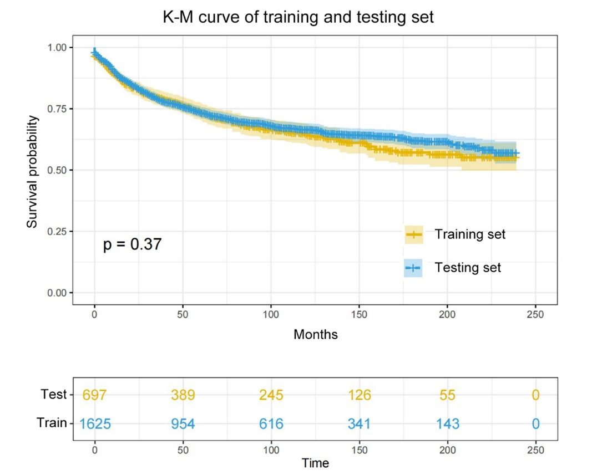
Fig. S1 Kaplan-Meier curve of training and testing sets. There was no statistically significant difference between the survival of training and testing sets in log-rank test (p =0.37).

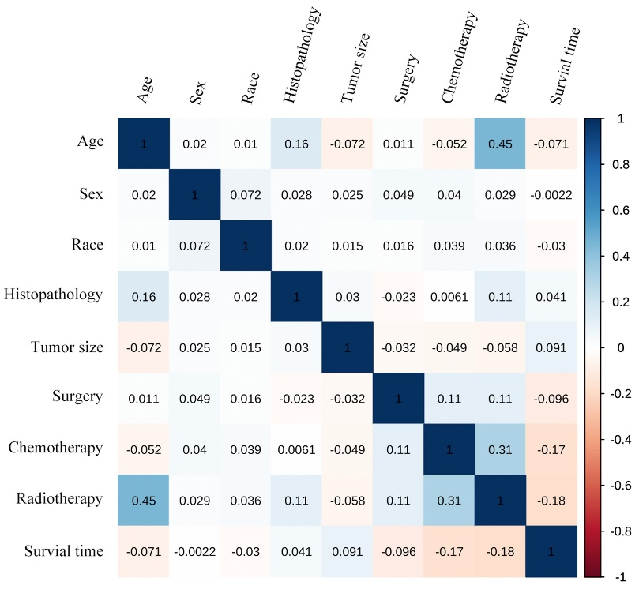
Fig. S2 The correlation coefficients were calculated for each pair of variables in the dataset. These coefficients represent the strength and direction of the relationship between the variables and range from -1 to +1. The correlation values are displayed using color depth, with values closer to -1 or +1 indicating a stronger negative or positive correlation, respectively.

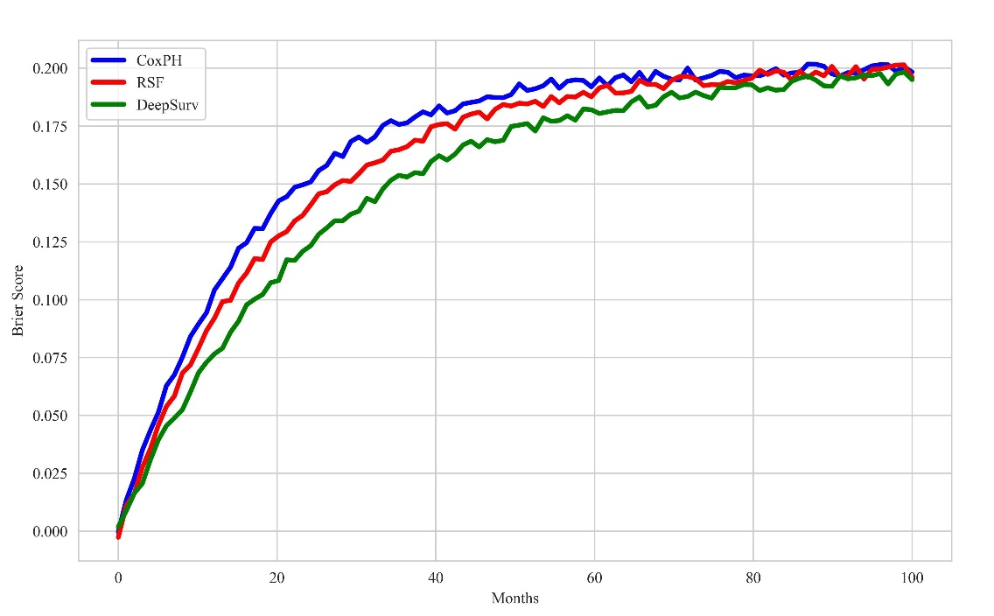
Fig. S3 A plot of the Brier Score as a function of survival time. As a benchmark, a reliable model should aim for a Brier score below 0.25.

